HW5

20184448 조민기

Prob 1

1)

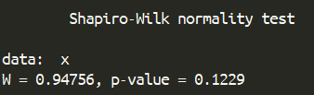  
The result of the Shapiro-Wilk test. P-value is grater than 0.05 which means the null hypothesis that this data follow the normal distribution is rejected.

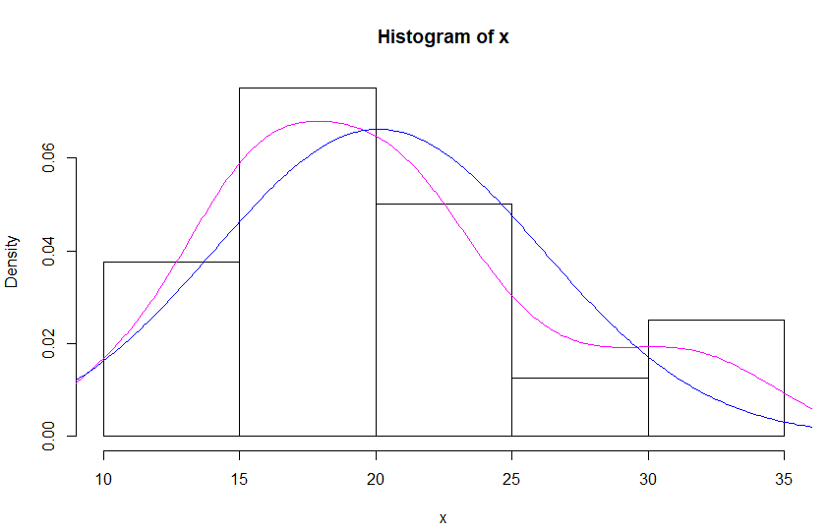  
The blue line indicates the normal distribution $N\left(μ_{x}, σ_{x}\right)$ where x is the mpg data.   
The violet line indicates the distribution of the x.

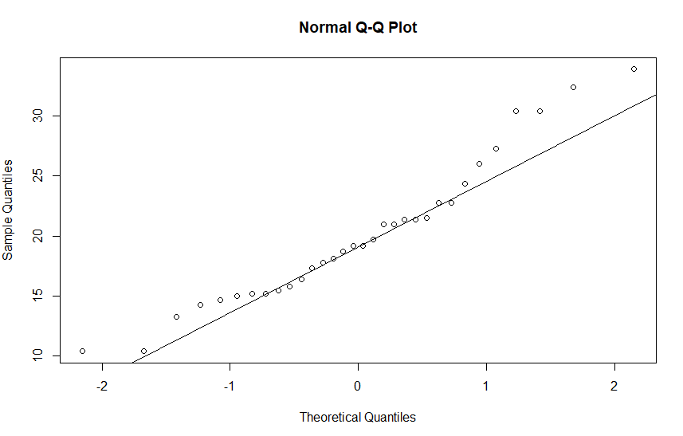  
Result of the QQ norm.

According to the result, the distribution of the x does not follow the Gaussian distribution.

2)

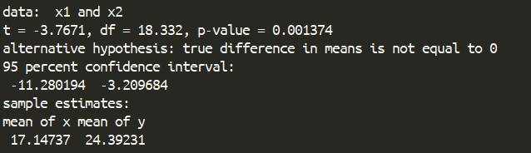

The mean of x1 is 17.14 and mean of y is 24.39 and the p value is smaller than 0.05. The true difference in means is not equal to 0.

Prob 2



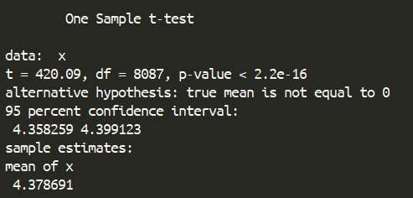

The 95% confidence interval is [4.358259, 4.399123]